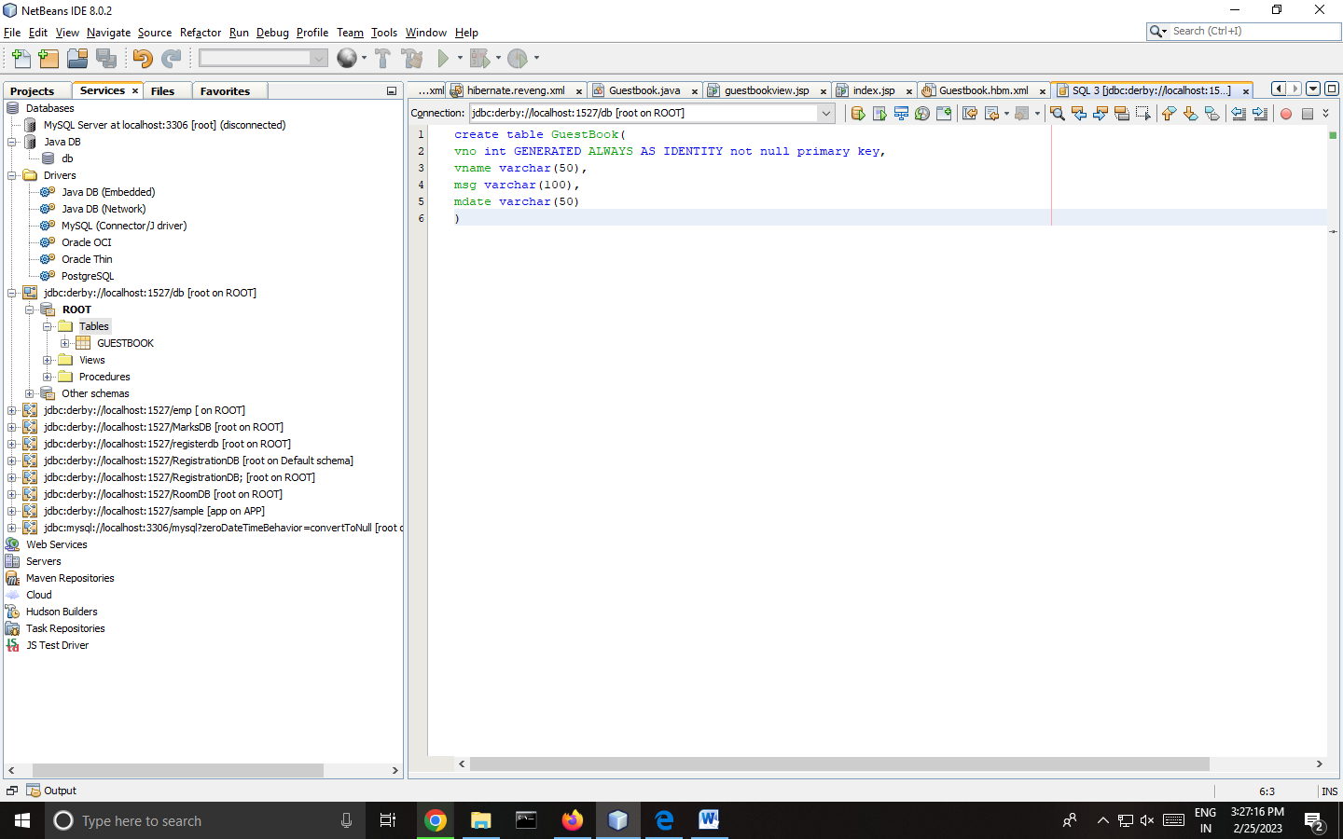

Step 1: Derby SQL Command:-

create table GuestBook(

vno int GENERATED ALWAYS AS IDENTITY not null primary key

,

vname varchar(50),

msg varchar(100),

mdate varchar(50)

)

**Step 2: Create a Hibernate Project :-**

File -> New Project -> Java Web -> Web application - > Next -> give the project name -> browse the location as required -> select the checkbox – “dedicated folder for storing libraries” -> Next Select glassfish server -> next Select frame work - hibernate -> select the respective database connection -> finish.

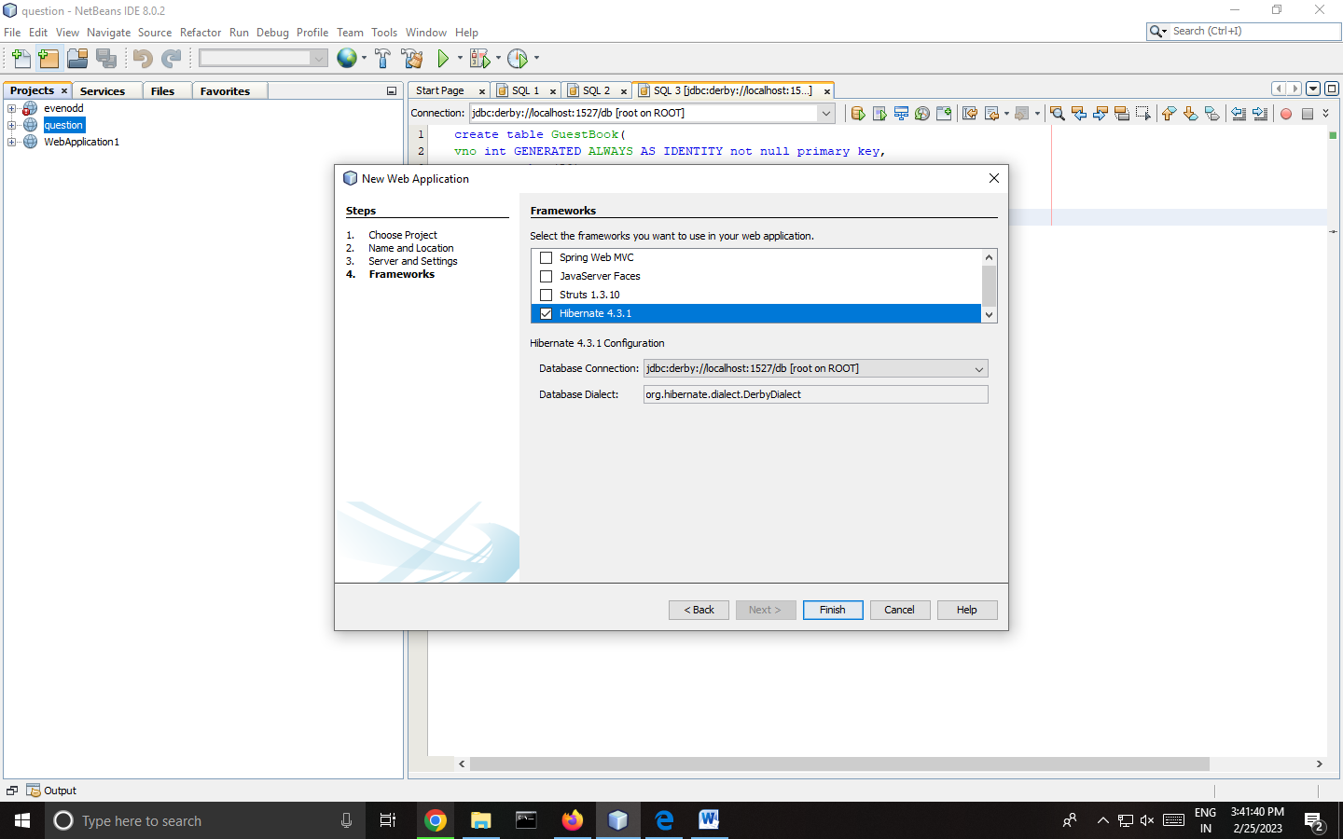

# Hibernate.cfg.xml

<hibernate-configuration>

<session-factory>

<property name="hibernate.connection.driver_class">org.apache.derby.jdbc.ClientDriver</property>

<property name="hibernate.connection.url">jdbc:derby://localhost:1527/Demo</property>

<property name="hibernate.connection.username">root</property>

<property name="hibernate.connection.password">root</property>

Add this click on source :- ( *exclude this parenthesis

<property name="hibernate.show_sql">true</property>

<property name="hibernate.hbm2ddl.auto">update</property> )

<mapping resource="hibernate/Guestbook.hbm.xml"/>

</session-factory>

</hibernate-configuration>

**Step 3: Adding Reverse Engineering File :-**

Right click on Project -> new -> other -> select Hibernate -> Hibernate Reverse Engineering wizard file type -> next -> file name (hibernate.reveng) , folder -> click on browse and select src->java -> next -> select guestbook table name from the available tables option -> click add ( select the checkbox – include related files) -> finish.

+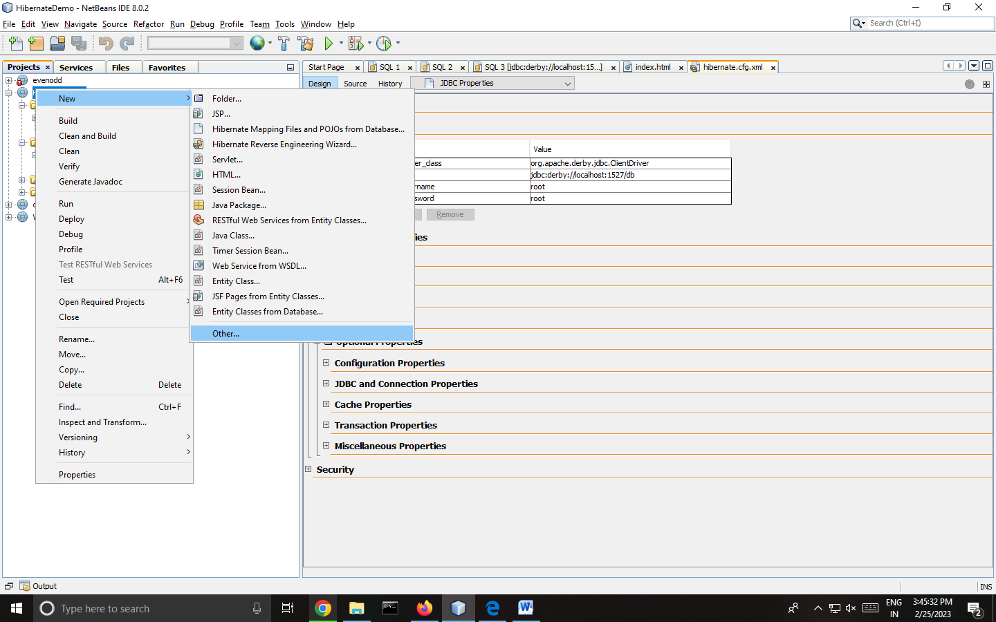

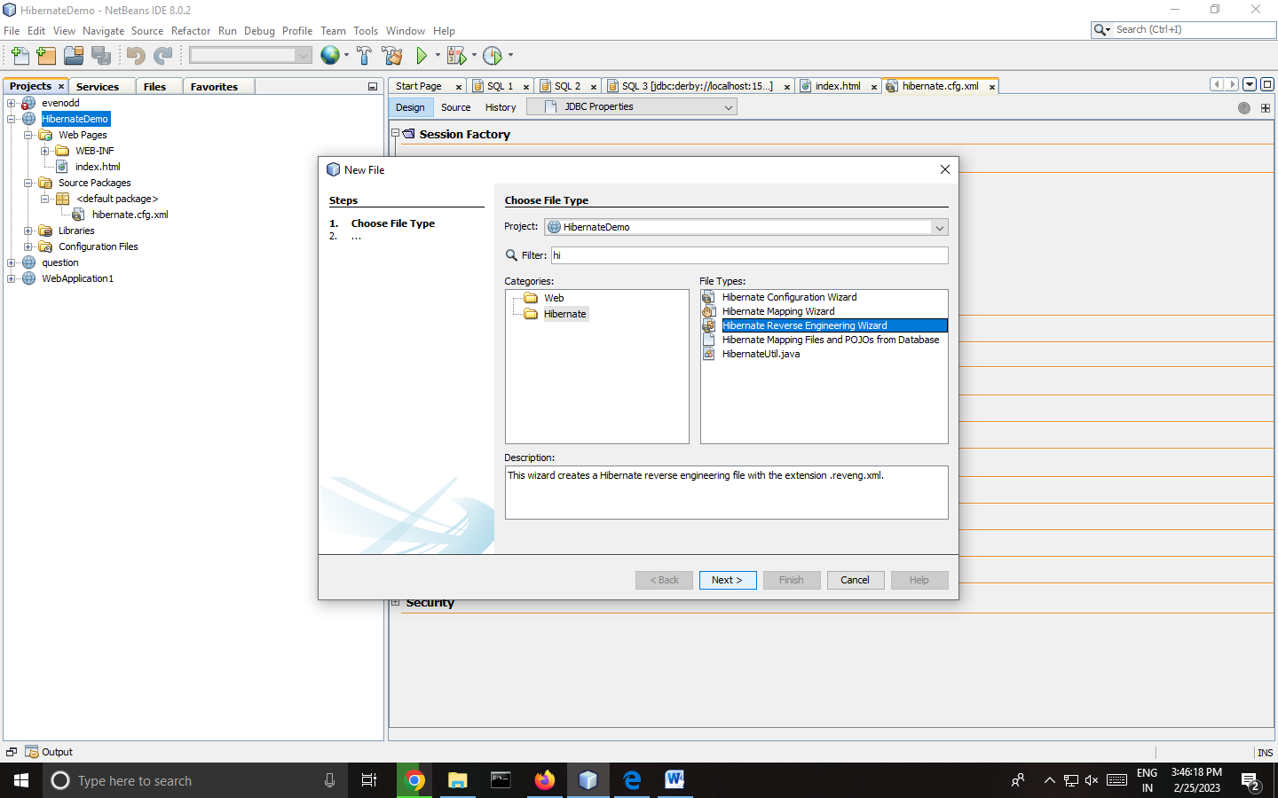

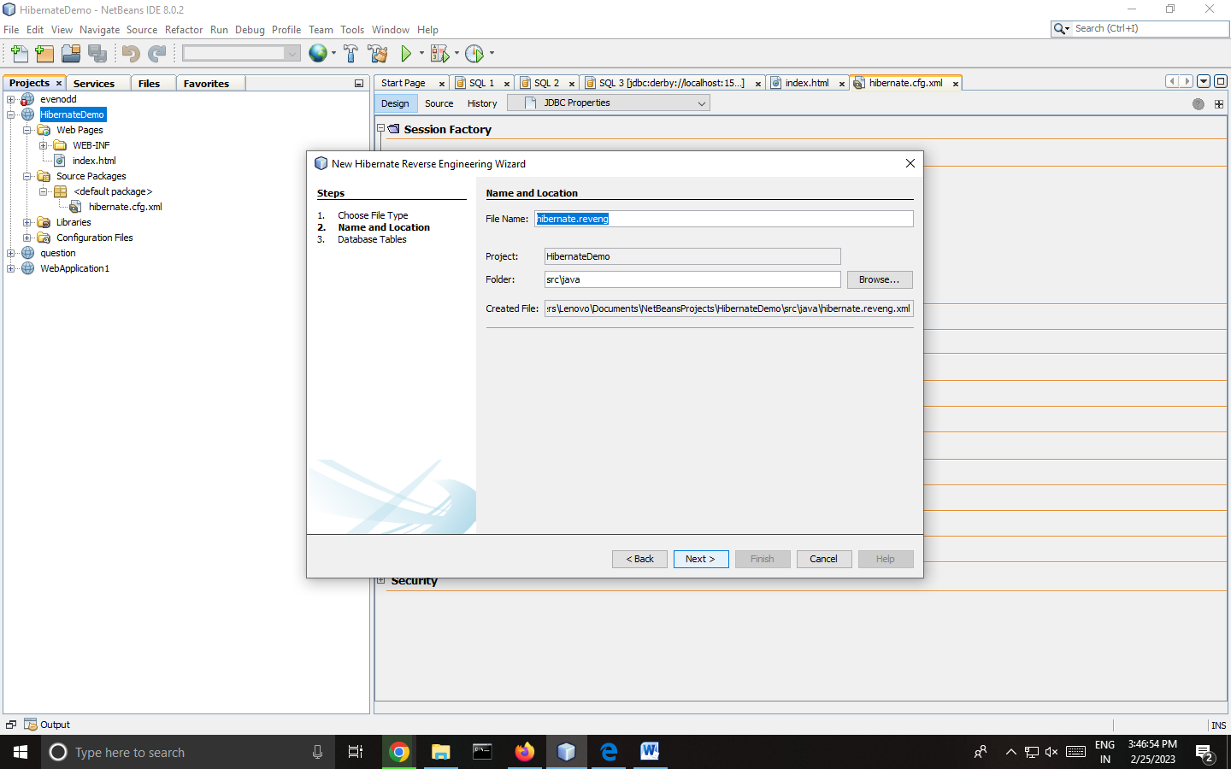

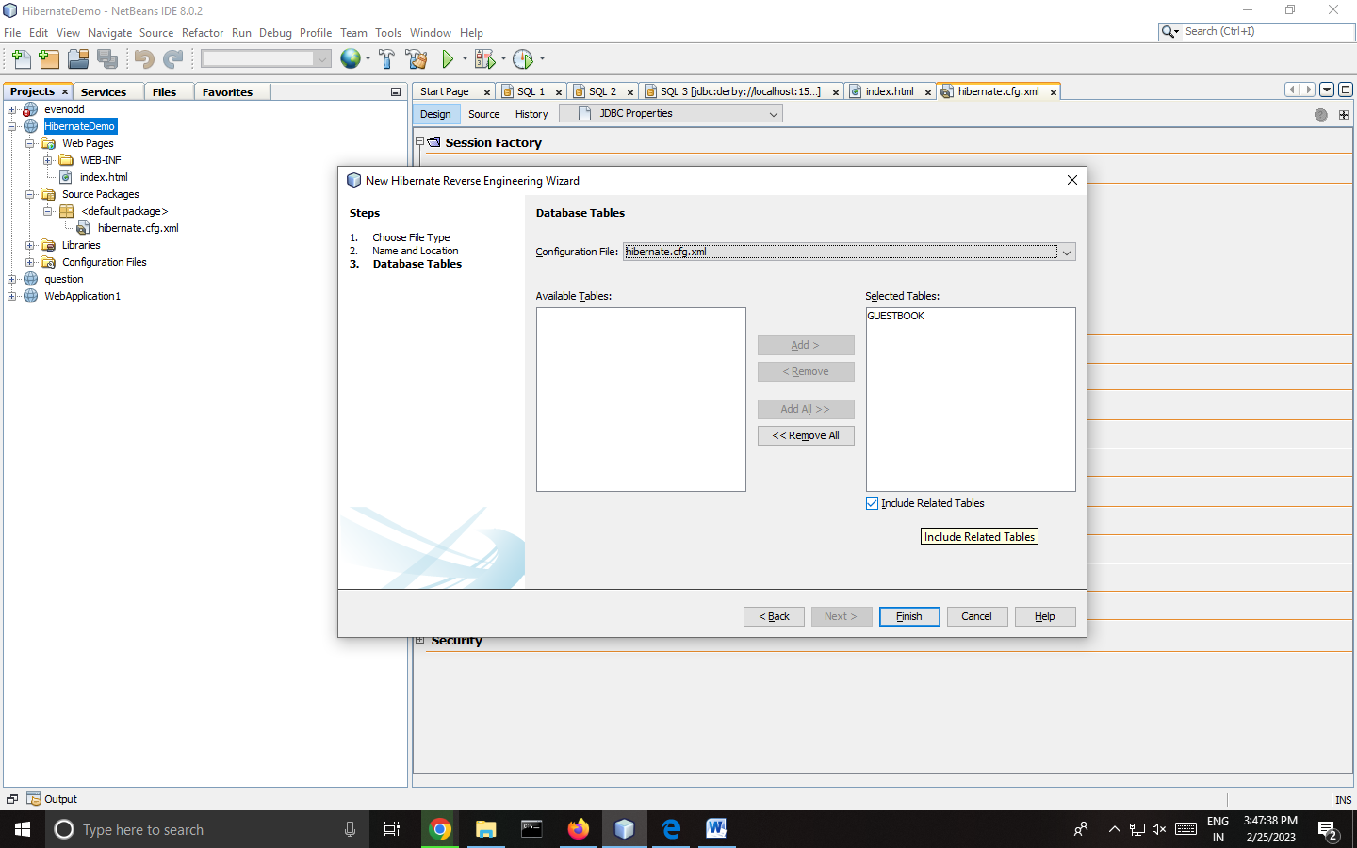

# Hibernate .reveng.xml

<hibernate-reverse-engineering>

<schema-selection match-schema="ROOT"/>

<table-filter match-name="GUESTBOOK"/>

</hibernate-reverse-engineering>

**Step 4: Adding Hibernate mapping files and POJOs from Database file type:-**

Right click on Project -> new -> other -> select Hibernate -> Hibernate mapping files and POJOs from Database file type) -> next -> keep the default configuration file name file name (hibernate.cfg) and Hibernate Reverse Engineering File (hibernate.reveng) -> type the package name (hibernate) -> finish.

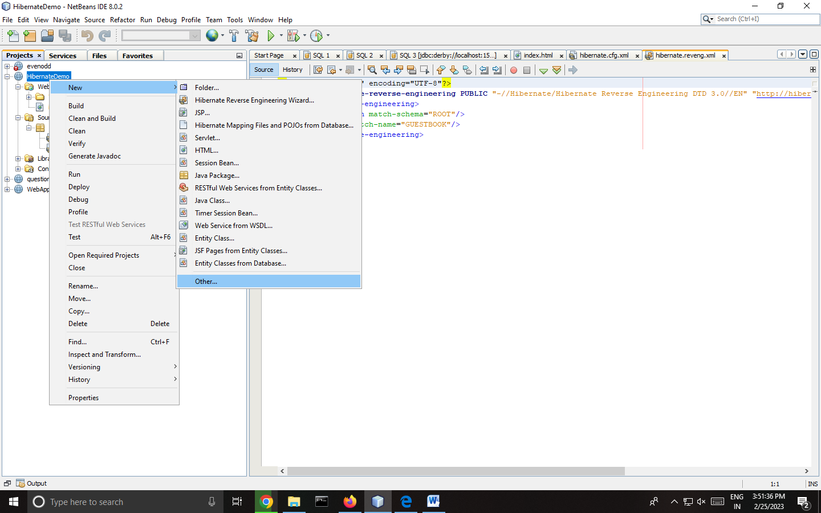

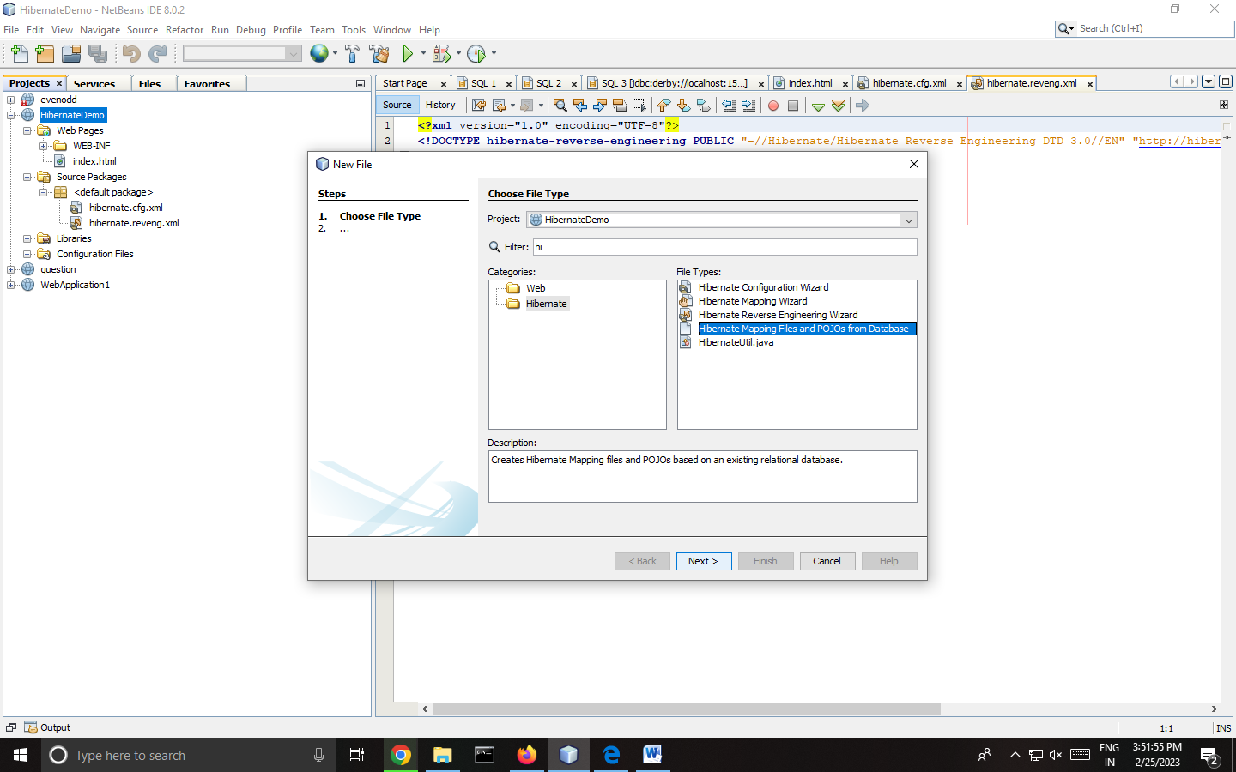

# Guestbook.hbm.xml

<?xml version="1.0"?>

<!DOCTYPE hibernate-mapping PUBLIC "-//Hibernate/Hibernate Mapping DTD 3.0//EN"

"http://www.hibernate.org/dtd/hibernate-mapping-3.0.dtd">

<!-- Generated 12 Feb, 2024 10:11:47 PM by Hibernate Tools 4.3.1 -->

<hibernate-mapping>

<class name="hibernate.Guestbook" table="GUESTBOOK" schema="ROOT" optimistic-lock="version">

Add this too :- (

<id name="vno" type="int">

<column name="VNO" />

<generator class**="identity**" />

</id>

Remove the parenthesis )

<property name="vname" type="string">

<column name="VNAME" length="50" />

</property>

<property name="msg" type="string">

<column name="MSG" length="100" />

</property>

<property name="mdate" type="string">

<column name="MDATE" length="50" />

</property>

</class>

</hibernate-mapping>

# Guestbook.java

package hibernate;

// Generated 12 Feb, 2024 10:11:47 PM by Hibernate Tools 4.3.1

*Add :- import javax.persistence.*;

/**

* Guestbook generated by hbm2java

*/

*Add this :-

@Entity

@Table(name = "GuestBook")

public class Guestbook implements java.io.Serializable {

@Id

@GeneratedValue(strategy = GenerationType.IDENTITY)

*Till here

private int vno;

private String vname;

private String msg;

private String mdate;

public Guestbook() {

}

public Guestbook(int vno) {

this.vno = vno;

}

public Guestbook(int vno, String vname, String msg, String mdate) {

this.vno = vno;

this.vname = vname;

this.msg = msg;

this.mdate = mdate;

}

public int getVno() {

return this.vno;

}

public void setVno(int vno) {

this.vno = vno;

}

public String getVname() {

return this.vname;

}

public void setVname(String vname) {

this.vname = vname;

}

public String getMsg() {

return this.msg;

}

public void setMsg(String msg) {

this.msg = msg;

}

public String getMdate() {

return this.mdate;

}

public void setMdate(String mdate) {

this.mdate = mdate;

}

}

**Step 5: Creating JSP File** :-

Right click on project -> new -> JSP -> filename -> guestbookview -> select radiobutton -> JSP file (Standard syntax) -> Finish

# Guestbookview.jsp

# <%--

# Document : guestbookview

# Created on : 12 Feb, 2024, 10:13:21 PM

# Author : khana

# --%>

# <%@page contentType="text/html" pageEncoding="UTF-8"%>

# <%@page import="org.hibernate.SessionFactory"%>

# <%@page import="org.hibernate.Session"%>

# <%@page import="org.hibernate.cfg.Configuration"%>

# <%@page import="org.hibernate.Transaction"%>

# <%@page import="java.util.List"%>

# <%@page import="java.util.Iterator"%>

# <%@page import="hibernate.Guestbook"%>

# <%!

# SessionFactory sf;

# org.hibernate.Session ss;

# List<hibernate.Guestbook> gbook;

# %>

# <%

# sf = new Configuration().configure().buildSessionFactory();

# ss= sf.openSession();

# Transaction tx=null;

# Guestbook gb=new Guestbook();

# try

# {

# tx=ss.beginTransaction();

# String name=request.getParameter("name");

# String msg=request.getParameter("msg");

# String dt=new java.util.Date().toString();

# gb.setVname(name);

# gb.setMsg(msg);

# gb.setMdate(dt);

# ss.save(gb);

# tx.commit();

# }

# catch(Exception e){ out.println("Error"+e.getMessage()); }

# try

# { ss.beginTransaction();

# gbook=ss.createQuery("from Guestbook").list();

# }

# catch(Exception e){ }

# %>

# <html>

# <head>

# <title>Guest View</title>

# </head>

# <body>

# Guest View

# Click here to go <a href="index.jsp"> BACK </a>

# <br><br>

# <% Iterator it=gbook.iterator();

# while(it.hasNext())

# {

# Guestbook eachrecord=(Guestbook)it.next();

# out.print(eachrecord.getMdate()+" ");

# out.print(eachrecord.getVname()+"<br>");

# out.print(eachrecord.getMsg()+"<br><hr>");

# }

# %>

# </body>

# </html>

**from here index make index.jsp

# Index.jsp

<%--

Document : index

Created on : 12 Feb, 2024, 10:14:17 PM

Author : khana

--%>

<%@page contentType="text/html" pageEncoding="UTF-8"%>

<!DOCTYPE html>

<html>

<head>

<title>Guest Book</title>

</head>

<body>

Guest Book <hr><br><br>

<form action="guestbookview.jsp" >

Name <input type="text" name="name" maxlength="20"><br>

Message <textarea rows="5" cols="40" maxlength="100" name="msg"></textarea>

<br><input type="submit" value="submit">

</form>

</body>

</html>

**Output:**

